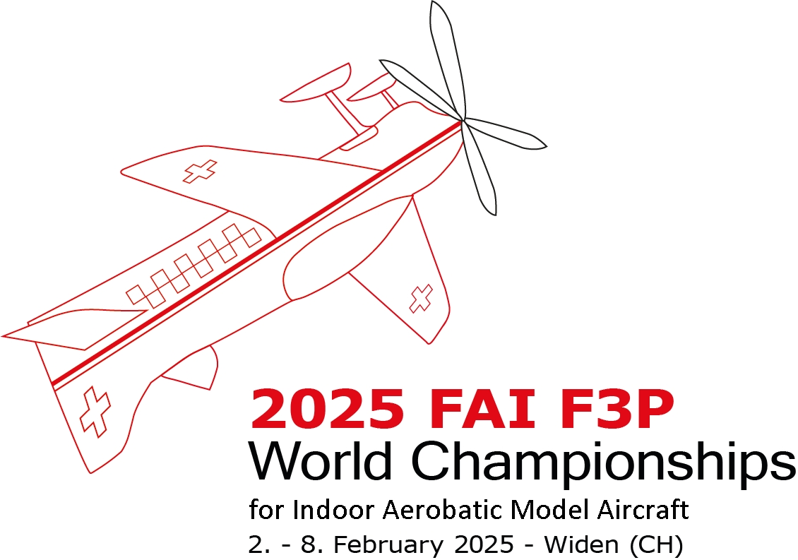
2025 FAI F3P
World Championships
For INDOOR Aerobatic model Aircraft
Widen AG - Switzerland
https://indoor2025.ch

LOGO

PRELIMINARY ENTRY FORM

The National Airsport Control of
intends to send a National Team as follows:
Team Manager (one only)
Number of F3P (A) competitors
Number of F3P (AFM) competitors
Number of F3P (A) junior competitors
Number of F3P (AFM) junior competitors
Approximate number of supporters

Name of the contact person to whom Bulletin N°2 should be addressed:
addressed
E-mail: | Phone:

Signature of NAC official |  | Date:
Please return this form before August 15^{t} 2024 to :  Adrian Eggenberger  Schnorpfenmatt 12  5507 Mellingen Switzerland  Email: adrian.eggenberger@softec.ch |  | Seal of NAC

